English Language Arts Lessons – Week of April 20th
Symmes Junior High

Lesson 1: Suspenseful Stories
Daily writing prompt: Use this opening line and continue the story, “I began to pick up the pace. The footsteps were getting closer, and I could tell the person — or the thing — was walking faster. I knew what they wanted, but I wasn’t about to give it up.”
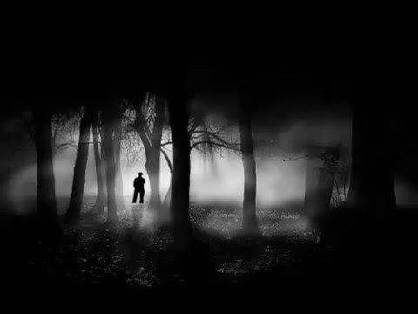
Activity: How to Make your Stories More Suspenseful
- Watch the following video and work through the attached questions. https://ed.ted.com/lessons/how-to-make-your-writing-suspenseful-victoria-smith#watch
- Use these skills to help you revise your story.

Lesson 2:
Daily writing prompt: Maya Angelou said, “I’ve learned that you can tell a lot about a person by the way they handle these three things: a rainy day, lost luggage, and tangled Christmas tree lights.” Tell a story in which a character must deal with one, two, or all three of these scenarios. How does your character respond?
Activity: Amazing Author’s
- Maya Angelou was born as Marguerite Johnson on April 4th, 1928, in St. Louis, Missouri and she was raised in St. Louis and Stamps, Arkansas. With over 50 honorary doctorate degrees, Dr. Maya Angelou became a celebrated poet, memoirist, educator, dramatist, producer, actress, historian, filmmaker, and civil rights activist. She published seven autobiographies, three books of essays, and several books of poetry, and she was credited with a list of plays, movies, and television shows spanning over 50 years.
- For today’s activity you will be writing a short biography of an Amazing Author. Pick an author that you think is amazing! You will be researching and writing about the author you have chosen. Aim for one or two paragraphs in which you answer the following questions:
  - Who are they?
  - What has happened during their life?
  - Where are they from? Where do they live now?
  - Why are they an amazing author?
- Before you start your research check out this mini-lesson on research skills.
  - https://youtu.be/LTJygQwYV84

Lesson 3: Fun with Fantasy
Daily writing prompt: Tell this story. You’re out catching fireflies and putting them into a jar. Later that night you realize you accidentally captured a fairy and she’s not impressed.
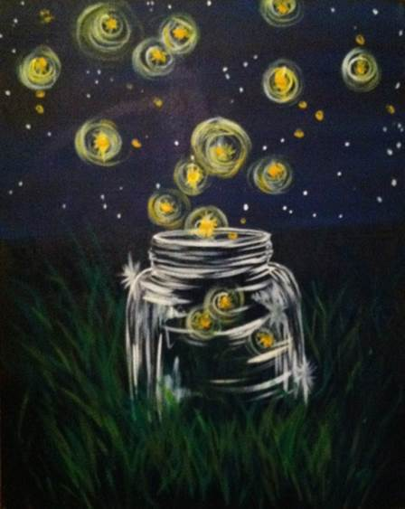
Activity: The Day it Rained Cats
- Read the story by Linda Sue Park https://scope.scholastic.com/issues/2015-16/050116/The-Day-It-Rained-Cats-by-Linda-Sue-Park.html
- Answer the following questions:
  - What does Sheera gain from the experience of learning to lev? What do you think she learns? Support your answer with details from the story.
  - What codes and conventions do you notice in the story? How do they impact the story?
  - Why do you think the author wrote this story? Explain your answer.

- Extension activities:
  - Imagine that Sheera has a younger cousin who will soon have to decide whether to learn to lev. Write a letter from Sheera to her cousin, offering advice on which path to choose. Include details from Sheera’s experiences.
  - This story explores a concept in literature called the hero's journey. Watch this video from TEDed to learn about the hero's journey. Then respond to the end of the video by writing down a way that you see the hero's journey in your own life or in the life of someone you know.

